Scope of Work: Axio Platform for GET Assessments & Feedback

1. Overview
Objective: Creation of a digital platform & mobile app for technical assessments of GET (Year1 to Year 3), continuous feedback capture (self, manager and mentor) & provide insights to various stakeholders (GET, YTM, Unit HR, CXO). The platform will enable multiple assessment methods-including MCQ-based evaluations, subjective assessments, and on-the-job/project-based reviews by managers and mentors-to provide a holistic view of technical proficiency, application capability, and progression over time.
Platform Name: Axio/Pro Assess/Skill Track

2. Scope
The scope of the platform is limited to technical capability assessment and evaluation of Graduate Engineer Trainees (GETs) across Year 1 to Year 3, including the structured capture of technical feedback The platform will include the following components:
- Technical Capability Assessment-
- MCQ-based technical assessments for evaluating conceptual and foundational knowledge.
- Subjective technical assessments for assessing problem-solving, analytical thinking, and application-based understanding.
- Phase-wise configuration of assessment types aligned to Year 1, Year 2, and Year 3 requirements.
- On-the-Job and Project-Based Technical Evaluation by manager and mentor
- Use of defined rubrics and evaluation criteria to ensure consistency.
- Scoring and Technical Progress Tracking
- Consolidated technical scorecards combining MCQ results, subjective assessment scores, and review-based evaluations.
- Weightage-based scoring across different assessment modes.
- Tracking of technical capability progression over time.
- Support role confirmation readiness flag to be raised by GET Manager

- Capture of Technical Feedback
- Structured capture of qualitative and quantitative technical feedback from GET, GET Manager, Technical Mentor, Unit L&D/Trainer, Unit Head, YTM
- Feedback focused on technical execution, problem-solving approach, adherence to standards, and quality of output.
- Documentation of technical development inputs and agreed action points.
- Role-Based Technical Dashboards
- Persona-wise dashboards displaying technical assessment results and insights for GETs, Managers, Technical mentors, Unit HR, YTM, and CXO leadership.
- SBU/Stream/Unit- cohort, and year-wise aggregation of technical capability data for monitoring and review.
- Allow option to download PPT format reports (It should be non-editable)
- STAR performers evaluation basis technical score and feedback provided by Manager & Mentor.
- Dates defined for evaluation and regular reminders emails for events in each phase - Allow evaluation due date tracking and platform could send email reminders

3. Assessment Framework

3.1 Assessment Events
Kindly refer to Annexure for GET Year 1 to Year 3 structure
Event | Description | Evaluation Type | Timeline
A | Mines to Metal Technical Assessment | MCQ | DOJ to DOJ+45
B | HTU Technical Training Assessment | MCQ/Subjective | DOJ+45 to DOJ+90
C | SOP Knowledge Assessment | Presentation | Month 5 to Month 11
D | External Training | MCQ/Subjective | Month 12 only
E | Year-1 Final Technical Review | Presentation & Interview | DOJ to Month 12
F | Unit-level Project Assessment (using PST) | Presentation | Month 13 to Month 18
G | Year-2 Final Technical Review | Presentation & Interview | Month 13 to Month 24
H | Business-level Project Assessment (using APST) | Presentation | Month 25 to Month 30
I | Year-3 Final Technical Review | Presentation & Interview | Month 25 to Month 36
RACI Matrix new.xlsx

3.2Instructions & Definitions
- PST: Problem-Solving Tools
- APST: Advanced Problem-Solving Tools
- Unit Technical Panel: The Unit Technical Panel shall comprise:
  - Department Head
  - Function Head
  - Senior GET
  - GET’s Reporting Manager
  - Skip Manager
  - Mentor

3.3 Scoring Methodology – Final Technical Reviews
Year 1 Final Technical Review – Score Computation The final technical score for GETs at the end of Year 1 shall be calculated using a weighted average of the following components:
- Event B HTU Technical Training Assessment: 20%
- Event C Assigned Project Assessment: 30%
- Event E Final Review Presentation & Interview: 50%
Year 2 and Year 3 Final Technical Review – Score Computation
The final technical score for GETs at the end of Year 2 and Year 3 shall be calculated using a weighted average of the following components:
Year 2
- Event F Assigned Project Assessment: 30%
- Event G Final Review Presentation & Interview: 70%
Year 3
- Event H Assigned Project Assessment: 30%
- Event I Final Review Presentation & Interview: 70%

3.4 Dashboard and Reports
- Dashboard for the following personas -
  - GETs: Their scores in each event with separate scores in each evaluation type and they will be grouped stream-wise/unit/SBU (>90 percentile, 50-90 percentile, <50 percentile). And feedback provided by every stakeholder.
  - Mangers: Can see GET performance in each assessment Event A to Event I. And their current standing within their stream/unit/SBU (All streams provided in annexure)
  - Technical Mentors: Can see GET performance in each assessment with all the evaluation type scores and feedback for GET from stakeholders
  - Units: Can see standing and scores of all GETs in their Unit with top & low performers rankings
  - YTM: All the GET scores with all the scoring details for all businesses & units
  - CXOs: A dashboard with business-wise, unit-wise & stream-wise GET technical performance and display of top performers and worst performers.

3.5 Feedback Types
- Manager Feedback: Mandatory for Events C to I (except D)
- GET Feedback: Mandatory for all Events A to I
- Technical Mentor Feedback: Mandatory for Events C to I (except D)
- Unit L&D Feedback, Unit Head Feedback, YTM Feedback: Mandatory for Events E, G, & I

4. System Enhancements

4.1 Data Model Additions
- GET Profile, Assessment Events, Feedback, Confirmation Decisions
- App for dashboards for ease of access and tracking
- Role confirmation readiness flags which can be raised by managers post technical score to satisfaction is achieved from assessment scores *

4.2 UI/UX Enhancements
- Dashboards for GETs, Managers, Mentors, YTM, Unit HR and CXOs
- Feedback panels for GETs, Technical mentors, Managers
- Automatic scheduled email notifications and due date reminders for evaluation

4.3 Governance & System Needs
- Role/Persona-based access to each user
- Live Data Refresh for all personas as soon as uploaded from the units.
- Event A and D scores will be shared by YTM
- Event B score will be shared by HTU
- Event C, E, F, G, H and I score will be shared by the Units

5. Annexure
- GET 3-year journey

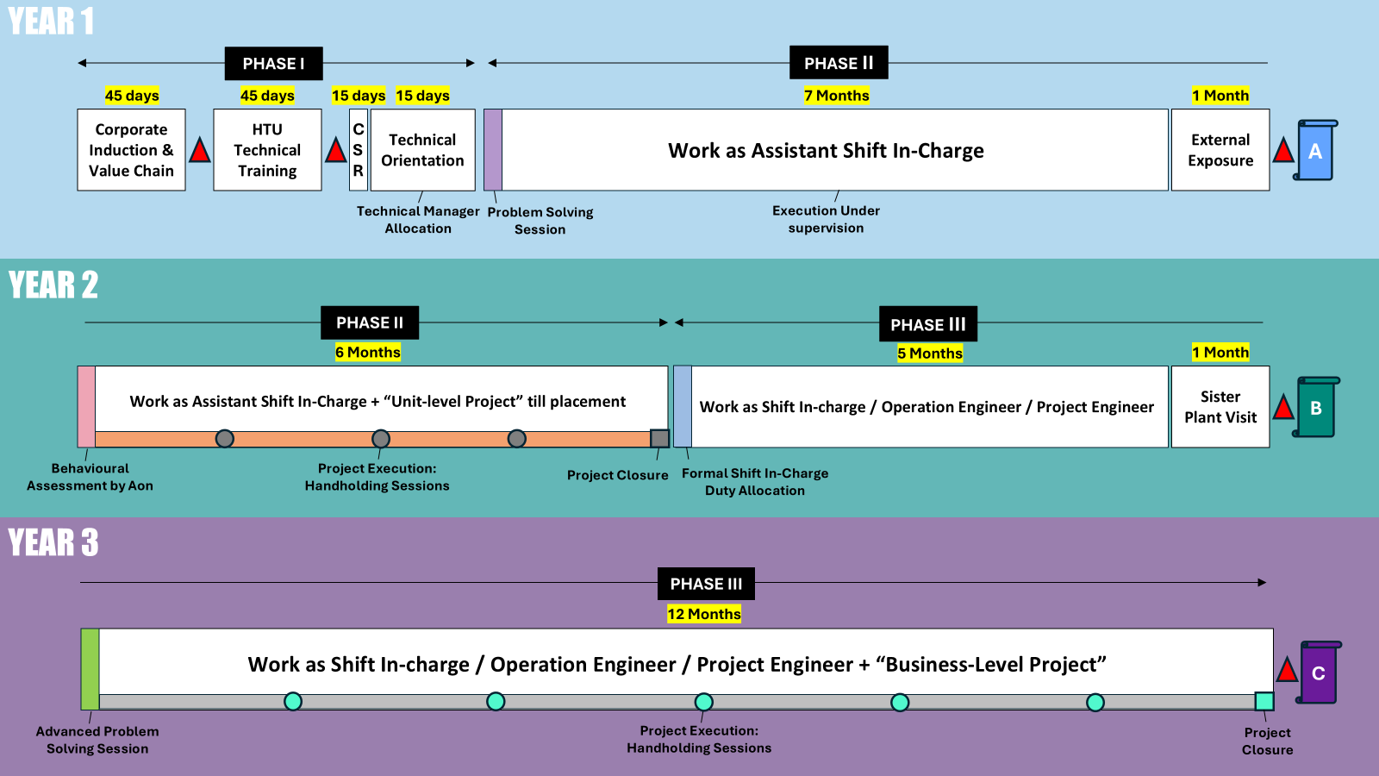
- The evaluations events in flowchart format.
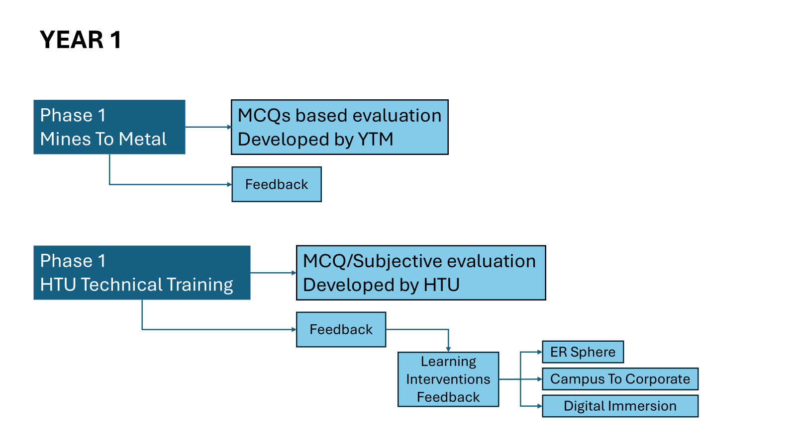

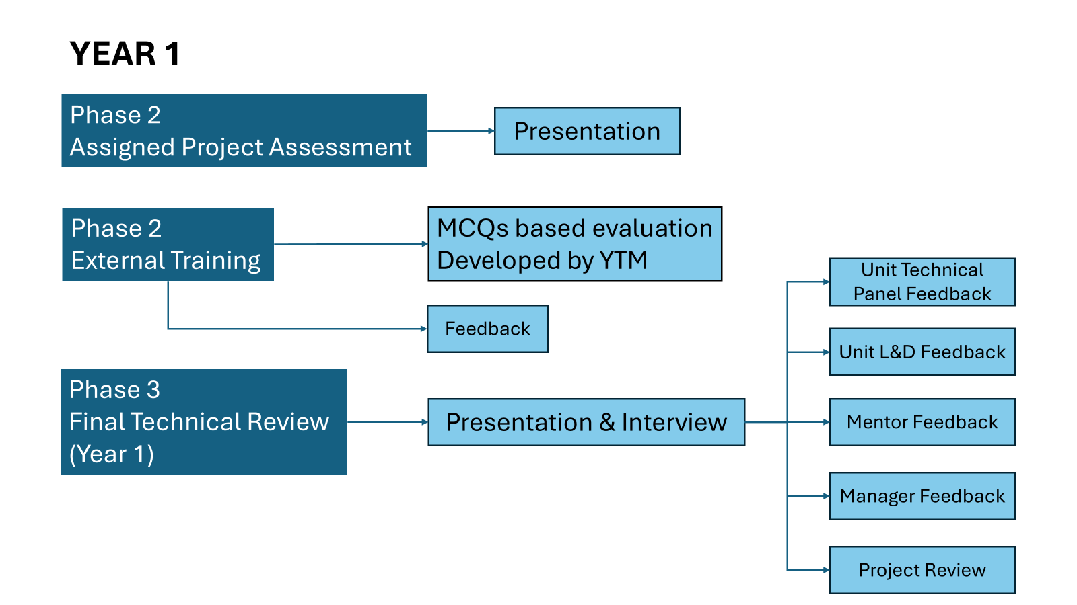
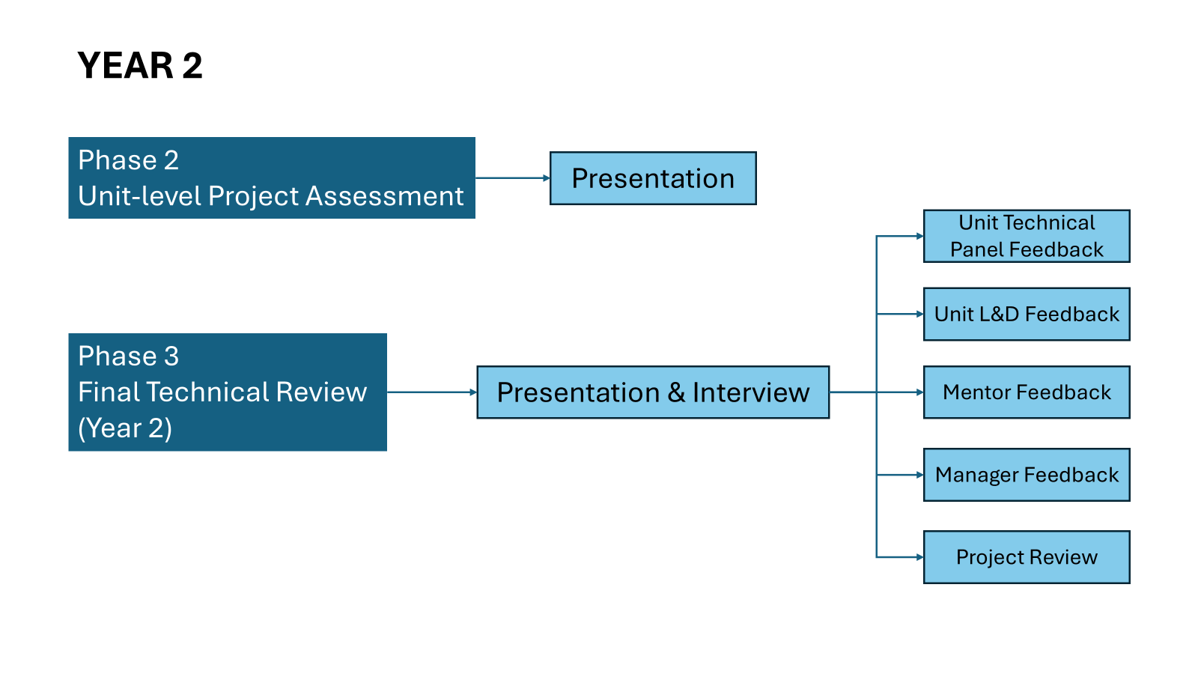

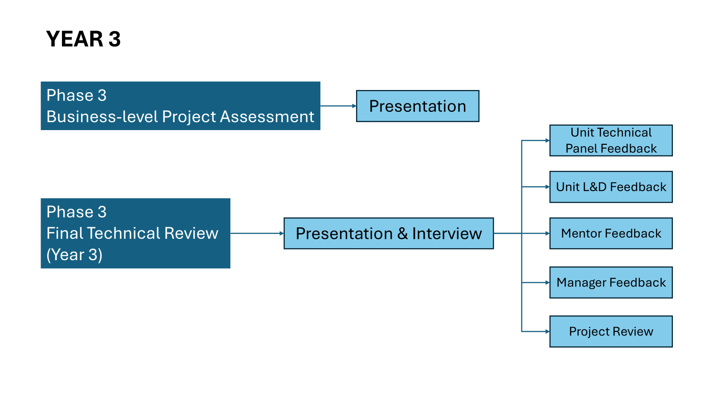
- Sample of Evaluation form, after evaluation result sheet, and feedback form of the phase respectively.

Sample Form_Phase I Evaluation.pdf
Sample Form_GET Feedback on Phase I.pdf
Phase I Evaluation - Set A - 4th Sept (Sheet1)
- Following are the streams in which GETs will be divided on the platform:
- School of Mines
- School of Smelter
- School of Refinery
- School of Power
- School of Downstream FRP Extrusion
- School of Copper
- Environment
- Digital & IT

Proctoring feature
Different Assessment Sets
Calendar view for timeline of events
Learning Development Tracking of events like Problem Solving Sessions, etc

